考试范围。

题型与范围：

选择题：15 x 2 = 30 分（15题，每题2分）

填空题：10 * 1 = 10 分（15个空格，每个空格1分）

判断题：10 * 1 = 10 分（10题，每题1分）

简答题：4 * 5 = 20分 (4题，每题5分)

综合题：3 * 10 = 30分(3题，每题10分)

试题需要A卷与B卷，原则上A与B卷在题目上必须有60%的不同。

* 选择题，填空题，判断题考点：

1. **Access network/Enterprise:** **Ethernet and WIFI的特点 Page 16**

Ethernet[以太网]：有线LAN接入

WiFi：无线[wireless]LAN接入

LAN：局域网

1. **End-to-end delays （四种类型，queue delay的不确定性）Page 35**

* (3)Consider sending a packet from a source host to a destination host over a fixed route,which of the end-to-end delay is variable?(**B**)

A.processing delay B.queuing delay C.transmission delay D.propagation delay

//哪一种端到端时延是可变的:排队时延

* Consider sending a packet from a source host to a destination host over a fixed route.Name the four factors of delay for the packet. Is the delay constant ? Why or why not? Identify which factor will most likely predominate (i.e. ,be the largest factor ) for 1M Byte Packets in a flow on the following different links.

a) 10 Mb/s LAN segment between two PCs in the same building

b) 1 Mb/s geosynchronous-orbit satellite (同步轨道卫星) link between the US and China

c) on the Internet between the US and China

transmission delay

propagation delay

queuing delay

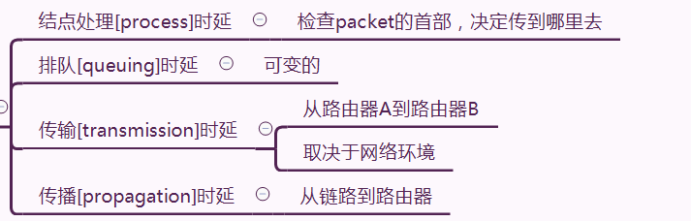

1. **Packet loss （主要原因，路由器缓存有限）page 41**
2. **End-to-end throughput （吞吐量瓶颈）Page 44**

* Suppose Host A wants to send a file to Host B, there are three links between A to B, and the rates of the three links are respectively R1=2 Mbps, R2= 1Mbps, and R3= 4 Mbps. If no any other traffic in the network, what is the throughput for the file transfer? ( )

A. 2 Mbps B. 1 Mbps C. 4 Mbps D. 7Mbps

1. **Encapsulation (app message, segment, datagram, frame等封装与解封装概念) Page 53**

message、segment、datagram、frame

就每一层的传输介质都是：上一层的传输介质+本层的header

1. Two important reasons that the Internet is organized as a hierarchy of networks for the purposes of routing are( **D** )
2. Message complexity and speed of convergence
3. Least cost and maximum free circuit availability
4. Link cost changes and link failure
5. Scale and administrative autonomy

//因特网组织为层次体系的原因是路由是……？

规模/比例 管理 的 自治

1. **Client-Server model and P2P model（特征）page 88**

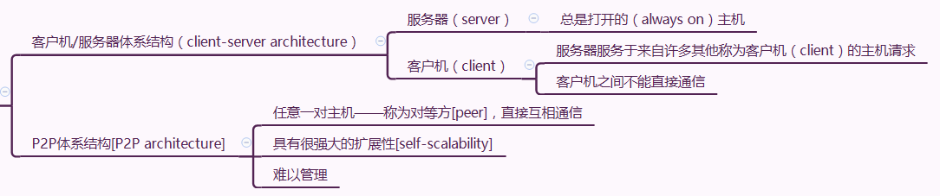

1. **Common APPs (File transfer, Email, Web, … ) and it underlying transport services (in terms of Data Loss, Throughput and Timing)（loss-tolerant/ bandwidth-sensitive/ Time-Sensitive） （主要应用对数据传输服务的基本要求，从data loss， 吞吐量和延迟/时间）Page 93**

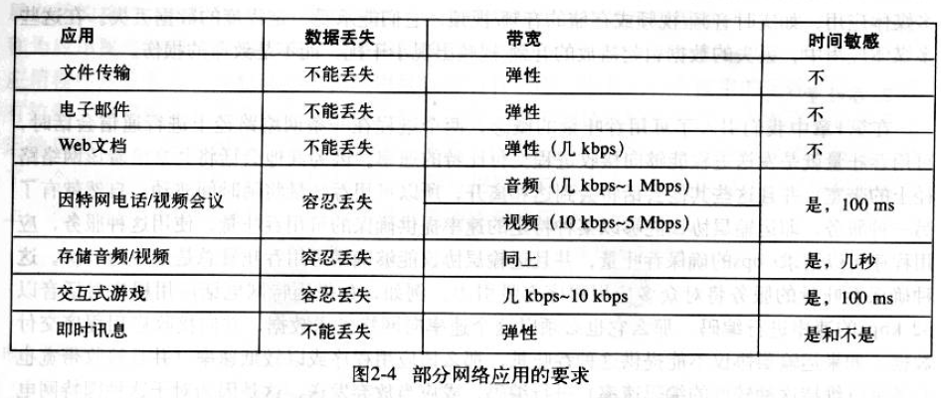

1. **Common APPs (File transfer, Email, Web, … ) and TCP or UDP (主要应用类型与TCP，UDP的关系)**

选择TCP：不能容忍丢失的app（file transfer、email、web）

选择UDP：时间敏感的app（网络电话）

1. **Web page/Object/URL （概念）page 99**

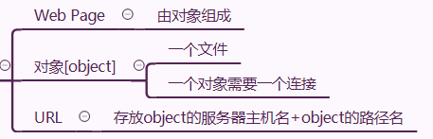

1. **HTTP request/response, Pull model for retrieving objects page 99 and 124**
2. **HTTP and** **stateless protocol/ (non-)** **Persistent/ HTTP method (GET, POST, HEAD, PUT, and DELETE)/****status codes (200, 404, 500等常见错误)**

When a Web page which consists of some text and three images is delivered by a **persistent** HTTP , there needs to establish connection for each object.**F**

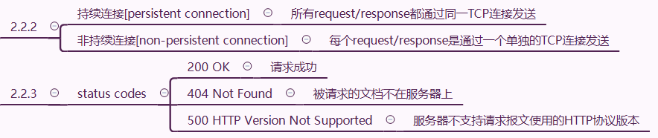

1. **FTP: control and data connection（概念）page 117**

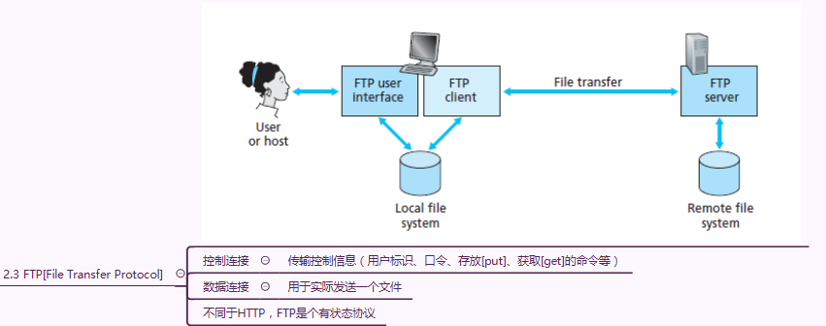

1. **Email：SMTP (push model for sending mails) and Mail Access Protocols (POP3, IMAP and HTTP, pull model to retrieving mails) （概念）page 125**

In the E-mail system , SMTP is a protocol used to sending E-mail , and POP3 is a protocol used to receiving E-mail. **T**

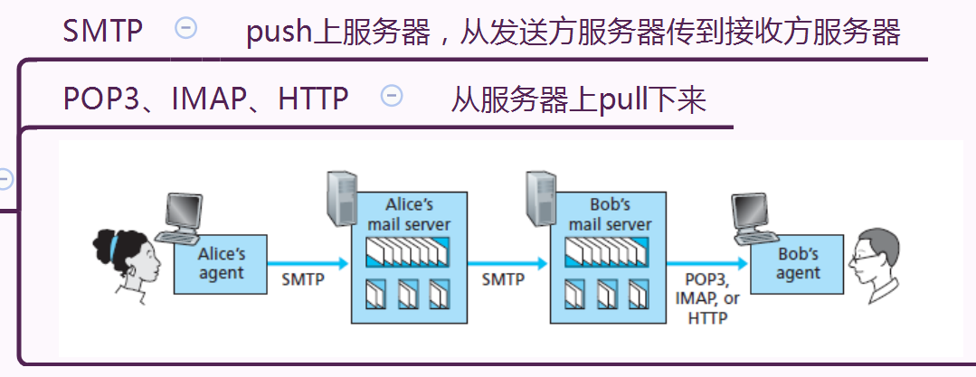

1. **Scalability of P2P Architectures in file distribution (概念) page 145**
2. **Logical communication channel at transport layer (端到端逻辑链路的概念) page 186**

A transport-layer protocol provides for logical communication between **application**

**processes running on different hosts**.

1. **Socket addressing，and {****connectionless and** **connection-oriented}Multiplexing and Demultiplexing at transport layer （概念）page 191**

* (6)An application of delivering the data in a transport-layer segment to the correct socket is called(**C**)

A.Multiplexing B.FDM C.Demultiplexing D.TDM

Socket=IP地址+端口号

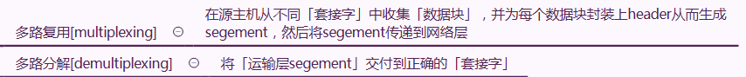

1. **Checksum and UDP (概念) page 202**

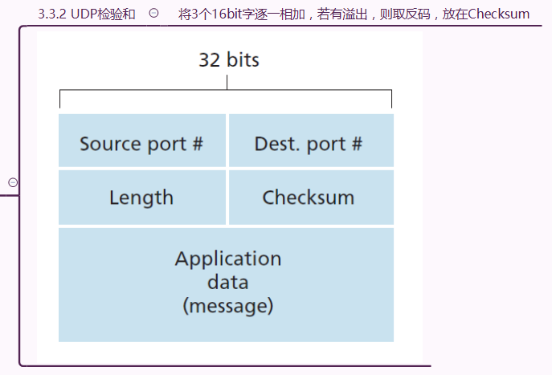

1. **Stop and wait and Pipelining[流水线]/sliding-window （概念）page 215**

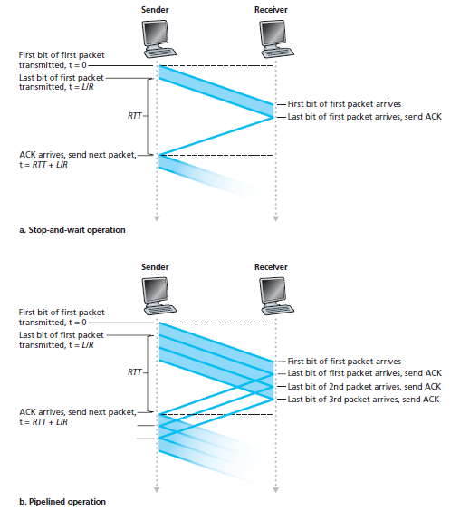

1. **Go-Back-N and Selective Repeat:** **cumulative acknowledgment (概念) page 222 and 224**

* For sliding window protocol of GBN,if the number of sequence is n(比特编码），then the **maximum size of sending window** is( **C** )

1. n B.2n-1 C.2n-1 D.2n-1

//SR:2n-1

* With a window size of 1,SR,GBN,and the alternating bit protocol are functionally equivalent. **T**

//在窗口1时，SR,GBN,the alternating bit protocol 在功能上是一样的，窗口1会自 动排除有可能无序的包。

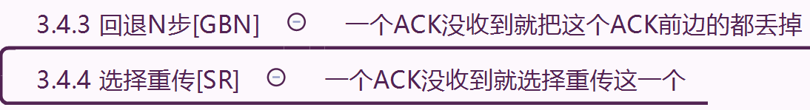

1. **Maximum segment size (MSS) and Maximum transmission unit (MTU) (概念) page 233**

MTU[最大传输单元]=40byte[TCP header+IP header]+MSS[最大报文段长度]

1. **TCP segment structure {****RST, SYN, FIN} and TCP connection management: three-way handshake (概念) page 234**

6bit的标志字段

RST：ppt都没有。。

SYN：三次握手时，server为了响应一个收到的SYN，分配并初始化连接变量和缓存，并返回SYNACK

FIN：关闭连接时，client向server发送FIN为1的segment，server返回FIN为1的中止segment

* When a TCP connection is established , the value of **Rcv Window** in the segment header is set by the **receiver.**

//接收窗口：指示receiver愿意接受的字节数量

* In the TCP , connection establishment of transport layer uses method of three-way **handshaking.**

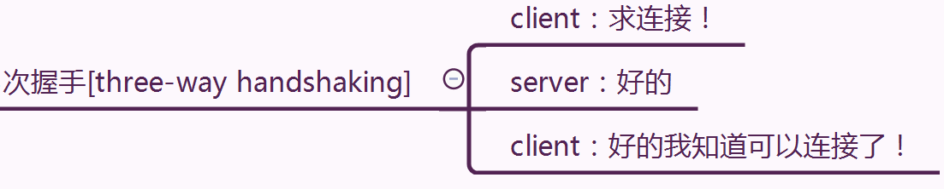

1. **Header length of TCP segment without options (概念) page 234**

20byte

* An application message with 20bytes header and 180bytes user data is encapsulated in a TCP segment , and then encapsulated in an IP datagram(no options fields).What is the percentage of overhead for each IP datagram?(**D**)

A.30% B.75% C.33% D25%

//overhead：开销，费用

IP datagram header=app message header(题目里给了是20byte)

+TCP header(20bytes)+IP header(20bytes)=60bytes

60/(180+60)=25%

1. **TCP Flow control and congestion control （概念区分）**

共同点：加在sender上

Flow control：取决于接收方接收和缓存报文的能力

Congestion control：取决于网络拥塞程度

* TCP provides a flow control service to its application to eliminate the possibility of the sender overwhelming the receiver.
* The goal of the flow control of TCP is same to that of the congestion control of it. **F**

1. **Router: Forwarding/Routing and Forwarding table and routing algorithm （概念与关系） page 308**

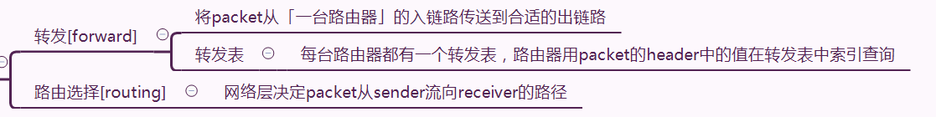

1. **Best-effort service model (概念) page 311**

尽力而为服务[best-effort service model]，极为简化的网络层服务模型

1. **Forwarding with longest prefix matching rule (概念) page 318**

longest prefix matching rule最长前缀匹配原则

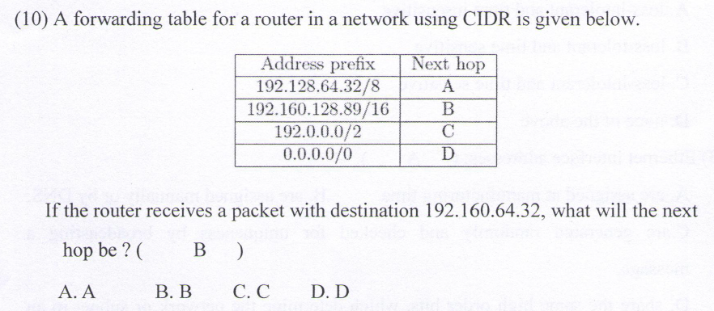

1. **IP datagram format (version,** **TTL, Header checksum) page 333**

**Version[版本号]：**只讨论IPv4/IPv6，分别为4/6

**TTL[Time To Live]：**

* The header of IP datagram has a time to live field, when the value of the field is 0, the datagram transmitted will be discarded

**Header checksum[首部校验和]：**帮助路由器检测收到的IP数据报中的比特错误

将header中的每2个字节当成一个数，用反码运算对这些数求和。

如果datagram携带的checksum和计算机算出来的不同，就有比特错误。

1. **DHCP (概念，功能) page 345**

DHCP[动态主机配置协议，Dynamic Host Configuration Protocol]

某组织获得一块地址后，为本组织内的主机与路由器接口逐个「分配IP地址」

即插即用

1. **ICMP (概念，功能) page 353**

* What is the ICMP used for ？ ( **C** )

A. Error reporting B. Used by ping C. A and B D. None above.

* The tool (command) that can be used to determine the number of hops to a destination and the round trip time (RTT) for each hop is traceroute

//traceroute 跟踪一台主机到世界上任意一台其他主机之间的路由

* Which protocol is used for Echo request or reply and Error reporting?( **B** )

A.IGMP B.ICMP C.SMTP D.CSMA

1. **IPv6 (128bits address space, 40-byte fixed-length header) 等概念**

IP地址长度：32bit→128bit

Header：20byte→40byte

流标签[Flow lable]：IPv4没有

1. **Routing algorithm: global and** **decentralized routing algorithms (概念与区别) page 365**

* The distance vector route algorithm depends on the complete network topology information. **F**

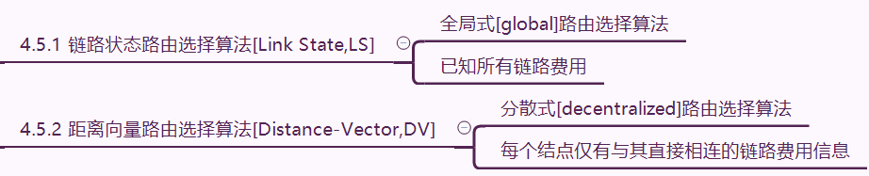

1. **Intra Routing in the Internet: RIP/DV-based and OSPF/LS-based page 384 and 388**

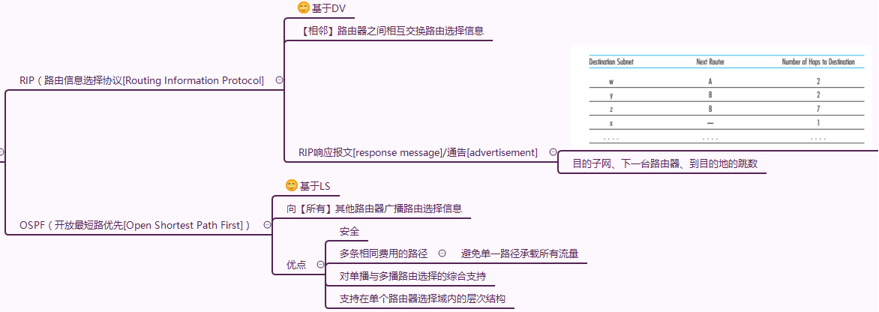

* Two routing protocols have been used extensively for routing within an autonomous system in the Internet:RIP protocol is based on **Distance Vector** routing algorithm and **OSPF** protocol is based on Link State routing algorithm.
* **RIP** advertisements typically announce **the number of hops** to various destination;

**BGP** updates, on the other hand, announce the **sequence of ASs on the routes** to the various destinations.

1. **Inter-AS Routing: BGP (****AS-PATH and Routing policy) (概念，原理) page 390**

BGP（边界网关协议[Broder Gateway Protocol]）

**AS-PATH**：包含了前缀的通告已经通过的那些AS

eg.如果AS2向AS1通告，那么AS1向AS3通告时，其AS-PATH中应为AS2 AS1

防止循环通告

**Routing policy中文书p267 超复杂：**

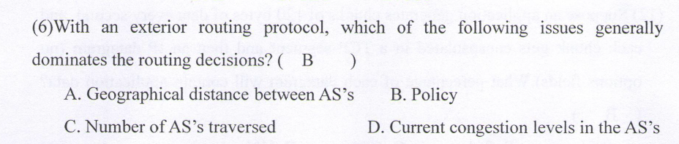

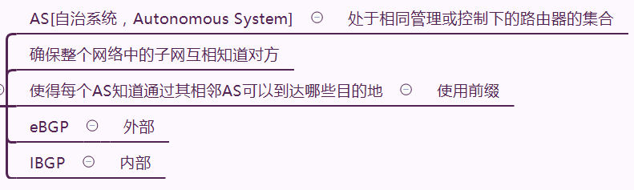

* 7. BGP is a distance vector routing protocol, but it has no routing-loop problem. **T**
* In inter-AS routing protocol of BGP , which of the following factors determine a good ‘route’?()

A.Routing Policy B.Reachability information C.A and B D.None of all

//4.6 BGP（边界网关协议[Broder Gateway Protocol]）

1. **Link-layer services: Framing, Link access,** **Reliable delivery, and** **Error detection and correction (概念) page 436**

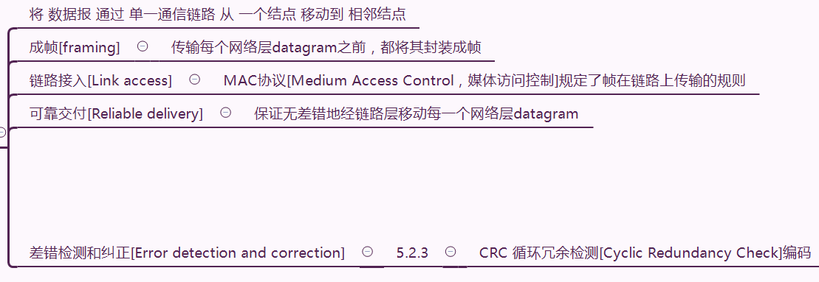

1. **medium access control (MAC) protocol/multiple access protocols/channel partitioning protocols, random access protocols, and taking-turns protocols (概念，特点) page 447**

* Multiple access control protocols include(**D**)

A.Channel partitioning B.Random access C.Taking turns D.All of the above

//5.3 多路访问链路协议[Multiple access protocols]

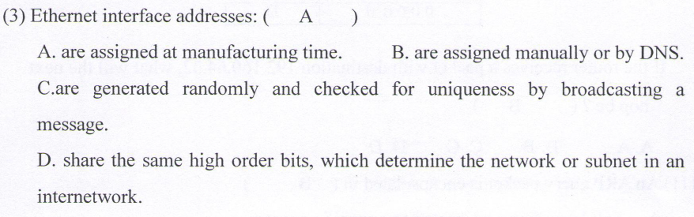

1. **MAC Addresses and ARP (概念，功能) page 462**

* The function of ARP protocol is converting IP address into MAC address.
* An ARP query packet is encapsulated in a link-layer broadcast frame. **T**

1. **Ethernet: repeater，hub, switch (概念，功能) page 470**

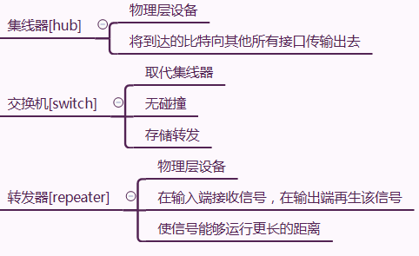

1. **Ethernet Frame Structure (MAC address 48 bits) (概念) page 471**

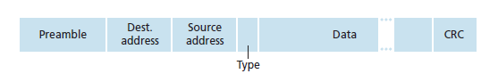

Preamble：前同步码

1. **Link-Layer Switches: Forwarding and Filtering/self-learning/plug-and-play (概念，原理) page 476 and 479**

* For the two-layer device of switch in Ethenet , how does it to establish the forwarding **table**?( **C** )

1. Manual configuration B.Shortest path algorithm

C.Self-learning D.Routing algorithm

//交换机如何建立转发表：自学习

* Which of following states about Switch of data link layer is error?( **C** )

A.Plug-and-play and self-learning

B.Buffer frame and selectively

C.All nodes connected to switch can collide with another one

D.Uses CSMA/CD to access segment

//接收端才会碰撞∴如果接收端不同就不会



1. **Properties of Link-Layer Switching (****Elimination of collisions, Heterogeneous links and** **Management.) (概念，原理) page 479**

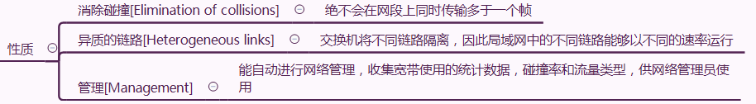

1. **Switches and routers (概念，原理与区别) page 480**

* 简答题考点：

1. Circuit switching and Packet switching (基本原理与特点，差异) Page 22 and 27 (A卷)

①Circuit switching：

原理：存储转发机制（接到一整个包后才会往外传）

特点：不适合实时服务，因为端到端时延不可预测

②Packet switching：

原理：频分复用/时分复用

特点：通信时会在终端间建立一条专用的端到端连接，适合实时服务

③差异：

Packet switching不考虑需求，预先分配链路的使用，Circuit switching按需分配链路的使用；

Packet switching适合实时服务，Circuit switching不适合。

1. Internet: network edge/access network/ network core/network of routers/ network of networks (Hierarchy，ISP等，对整个Internet架构的整体认识) page 32 (B卷)

network of networks：被端系统接入的ISP自身必须互联

1. TCP/IP and ISO OSI model Protocol layers/stacks and service models (分层架构，各个层次的基本功能,依赖下层服务，为上层提供服务的思想) Page 47 (A卷)

直接看xmind和txt

1. Web Caching/Proxy Server and Conditional GET/Local caching. （原理，计算分析） Page 111 and 114 (B卷)

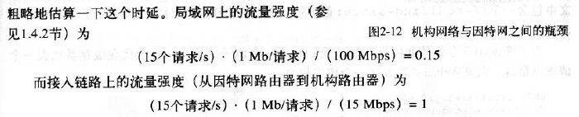

1. **DNS systems（层次结构，基本功能与查询过程:** **Iterative迭代的 and Recursive递归的，负载均衡）（A卷）**

往年题：DNS system is a established database in which **resource records** are stored.

* 往年题：Domain Name System (DNS) uses a distributed approach as opposed to a single server. Why?

Assume a client needs to find the IP address of www.newpool.org using the DNS. And assume the client has a local DNS server, but that server does not have any addresses cached. What are the DNS servers that are queried (in order) to find the IP address?

①Why: A distributed hierarchy of servers gives better scalability and does not present a single point of failure.

一个服务器的分布式层次提供了更好的可扩展性，不存在单点故障。

1. Principles of reliable data transfer (mechanisms: checksum, timer/timeout, sequence number, acknowledgment, pipelining) (基本原理) page 230 (B卷)

* (3) Try to describe the main principles of reliable data transfer for GBN as figure 1.

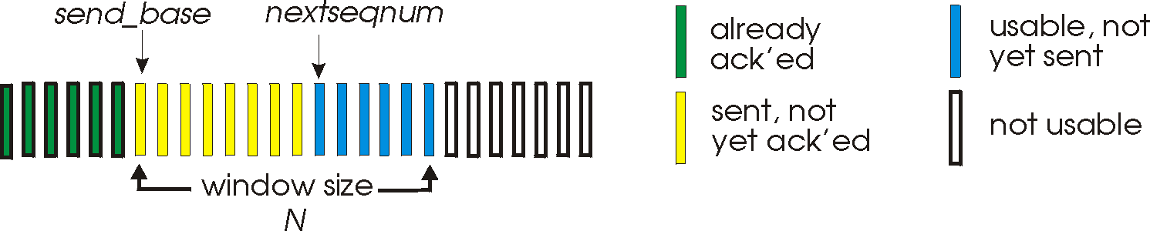

Figure 1 GBN window mechanism

1. “window” of up to N, consecutive unack’ed pkts allowed.
2. ACK(n): ACKs all pkts up to, including seq # n - “cumulative ACK”
   1. may receive duplicate ACKs (see receiver)
   2. Only a single timer for the oldest transmitted but not yet acknowleged.

timeout(n): retransmit pkt n and all higher seq # pkts in window

1. **Router: Where Does Queuing Occur? And why? (原理) page 327 (A卷)**

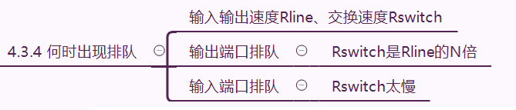

1. **IP Datagram Fragmentation in IPv4 and IPv6 (计算题,原理题), page 335 and 358 (B卷)**

* Consider sending a 4000 byte datagram into a link that has an MTU of 1500 bytes(B)

A.3 fragments are created with offset field value 0,1000,2000 respectively

B.3 fragments are created with offset field value 0,185,370 respectively

C.3 fragments are created with offset field value 0,1000,1000respectively

D.None of these above

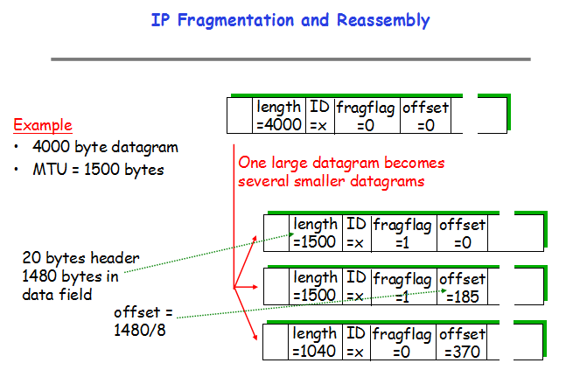

1. **Hierarchical Routing： Intra-AS/Inter-AS routing and hot-****potato routing. (原理，功能) page 379 (A卷)**
2. **Cyclic Redundancy Check (CRC) （原理与计算）page 443 (B卷)//看过就忘**
3. The message D=1010001101 is transmitted using the CRC method described in class using the generator polynomial G= x5+x4+x2+1.
4. What is the transmitted message T.

T=101000110101110

T=1010001101,01110(即D,余数)

G化为 110101（ G=1*x5+1*x4+0*x3+1*x2+0*x1+1*x0.）

D,0/G即1010001101,00000/110101 得到余数R=**1110**

补一位到5位（和G的最高位一样是5）得到01110

1. How does the receiver check whether the message T was transmitted without error?

receiver计算T/G，余数为0就是没有差错

1. **CSMA with collision detection (CSMA/CD) （原理）page 456 (A卷)**

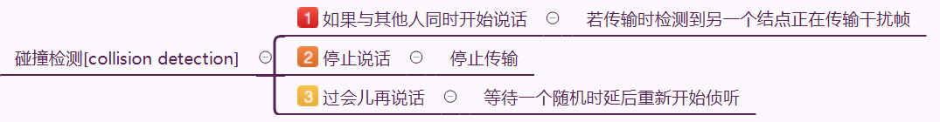

1. Link-Layer Switches：Self-Learning for building switch table (B卷)

* 综合题考点：

1. **TCP Sequence Numbers and Acknowledgment Numbers (计算题，原理题) page 235 (A卷)**

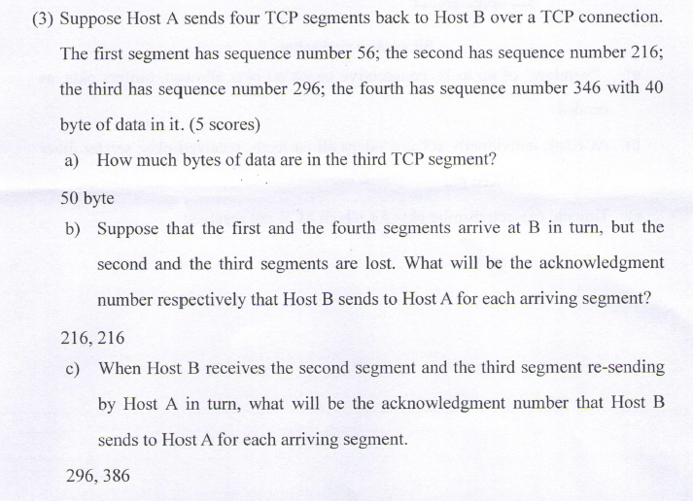

1. **TCP congestion-control algorithm （TCP Tahoe and Reno）{slow start，Congestion Avoidance，Fast Recovery} (计算题，原理题) page 276 (B卷)**

(2) Assume the following graph shows the behavior of a TCP congestion control, answer each question with a short discussion justifying your answer.



a) Identify the intervals of time when TCP slow start is operating.

b) Identify the intervals of time when TCP congestion avoidance is operating.

c)After 14th transmission round,is segment loss detected by a triple duplicate ACK or by a timeout? And which version of TCP protocol(Reno or Tahoe) is used base on this information?

d) During what transmission round is the 50th segment sent?

e) Assuming a packet loss is detected after the 23rd round by the receipt of a triple duplicate ACKs, what will be the values of the congestion window size and Threshold?

a)[1,6],[20,23]

b) [6,14],[15,19]

c)A triple duplicate ACK; Reno

d) 6

e) 4, 4

1. **IPv4** **CIDR[无类别域间路由选择] addressing and subneting (计算题，原理题) page 338 (A卷)**

(4) Consider a subnet with prefix 222.201.130.64/26. Give an example of one IP address(of form xxx.xxx.xxx.xxx) that can be assigned to an interface in this network. Suppose an ISP owns the block of addresses of the form 222.201.130.64/26. And **suppose it wants to create four subnets from this block, with each block having the same number of IP addresses.** What are the prefixes(of form a.b.c.d/x) for the four subnets?

222.201.130. 64~ 222.201.130.127//一整个ISP的子网范围：~~222.201.130.01~~00,0000-~~222.201.130.01~~11,1111

//将ISP均分成4个子网

Four subnets: 222.201.130.64/28//~~222.201.130.0100~~,0000

222.201.130.80/28//~~222.201.130.0101,~~0000

222.201.130.96/28//~~222.201.130.0110,~~0000

222.201.130.112/28//~~222.201.130.0111~~,0000

1. **Network Address Translation and Private Network (NAT) (原理题) page 349 (B卷)**
2. Link-State Algorithm (计算题，原理题) page 367 (A卷)
3. Distance-Vector Algorithm (计算题，原理题) page 371 (B卷)

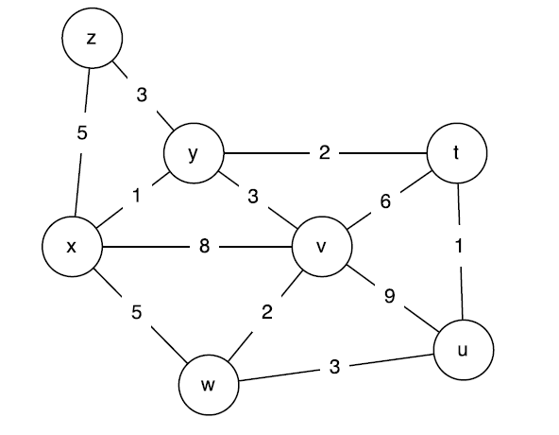

(1) Consider the following network. With the indicated link costs, use Dijkstra’s shortest path algorithm to compute the shortest path from x to all network nodes.

While selecting the next node, if several nodes have the same min cost, select the one with lowest id, (e.g., if t and v have the same min cost, then select t).

Please show how the algorithm works by filling out the following table.



Sending a

1 x ∞ ∞ 8,x 5,x 1,x 5,x

2 xy 3,y ∞ 4,y 5,x 4,y

3 xyt 4,t 4,y 5,x 4,y

4 xytu 4,y 5,x 4,y

5 xytuv 5,x 4,y

6 xytuvz 5,x

7 xytuvzw 3,y 4,t 4,y 5,x 1,x 4,y

1. IP Datagram off the Subnet (原理题) page 468 (A/B卷)